

**SAVEETHA SCHOOL OF ENGINEERING**

**SAVEETHA INSTITUTE OF MEDICAL AND TECHNICAL SCIENCES**

**CAPSTONE PROJECT REPORT**

**PROJECT TITLE**

**HUMAN RESOURCE ANALYSIS**

**ITA0464-Statistics with R Programming for BioInformatics**

Submitted

by

**SRUTHI ROSILINE A (192221015)**

Guided by

Dr. S. Sivagami

Associate Professor

Data Vista,

Department of Computer Science and Engineering

**ABSTRACT:**

This research delves into the dynamic landscape of Human Resources, analyzing its strategic impact on organizational success. Addressing challenges such as talent acquisition and retention, the study explores innovative HR practices like data analytics and AI to enhance decision-making. Emphasis is placed on fostering a positive organizational culture that aligns with business goals. The research employs a mixed-methods approach, incorporating insights from HR professionals, leaders, and employees. By examining the intersections between HR strategies and overall performance, this study offers practical recommendations for optimizing human capital management. Ultimately, it serves as a valuable resource for practitioners and leaders navigating the complexities of contemporary HR practices.

**INTRODUCTION:**

In the fast-paced and ever-evolving landscape of today's business environment, Human Resources (HR) plays a pivotal role in shaping organizational success[1]. The strategic management of human capital has become a critical imperative for businesses seeking to thrive amidst global competition, technological advancements, and shifting workforce dynamics. This study embarks on a comprehensive analysis of HR practices, delving into their multifaceted impact on organizational performance and employee engagement.

As businesses recognize the importance of their human capital as a key differentiator, HR professionals are navigating a complex terrain marked by talent shortages, changing demographics, and the integration of cutting-edge technologies. Understanding the strategic dimensions of HR is no longer a mere administrative function but a dynamic and integral part of organizational strategy.

This research endeavors to unravel the complexities of HR in contemporary workplaces, exploring innovative practices, challenges, and the alignment of HR strategies with overarching business objectives. By examining the intersections between HR practices and organizational success, this study seeks to provide valuable insights for HR practitioners, organizational leaders, and researchers alike, contributing to the ongoing dialogue on effective human capital management in the 21st century.

By examining the intersections between HR practices and organizational success, this study seeks to provide valuable insights for HR practitioners, organizational leaders, and researchers alike, contributing to the ongoing dialogue on effective human capital management in the 21st century.

**RESEARCH PLAN:**

**GANTT CHART:**

|  |  |  |  |  |  |  |
| --- | --- | --- | --- | --- | --- | --- |
| S.NO | DESCRIPTION | 01.03.24  DAY-01 | 02.03.24  DAY-02 | 04.03.24  DAY-03 | 05.03.24  DAY-04 | 06.03.24  DAY-05 |
| 1. | Problem Identification |  |  |  |  |  |
| 2. | Introduction |  |  |  |  |  |
| 3. | Analysis, Design |  |  |  |  |  |
| 4. | Implementation |  |  |  |  |  |
| 5. | Conclusion |  |  |  |  |  |

**CODE:**

library(readr)

library(caret)

library(e1071)

train<-read.csv("FILE PATH.csv")

test<-read.csv("FILE PATH.csv”)

target_column <- 'target'

train <- na.omit(train)

train$target <- as.factor(train$target)

features <- c('city_development_index', 'training_hours')

X <- train[, features]

y <- train[, target_column]

set.seed(42)

split <- createDataPartition(y, p = 0.8, list = FALSE)

X_train <- X[split, ]

X_test <- X[-split, ]

y_train <- y[split]

y_test <- y[-split]

nb_model<-naiveBayes(y_train~.,data=data.frame(cbind(y_train, X_train)))

y_pred <- predict(nb_model, newdata = data.frame(X_test))

accuracy <- sum(y_pred == y_test) / length(y_test)

classification_rep <- confusionMatrix(y_pred, y_test)

cat("Accuracy:", accuracy, "\n")

print(classification_rep)

**OUTPUT**

:

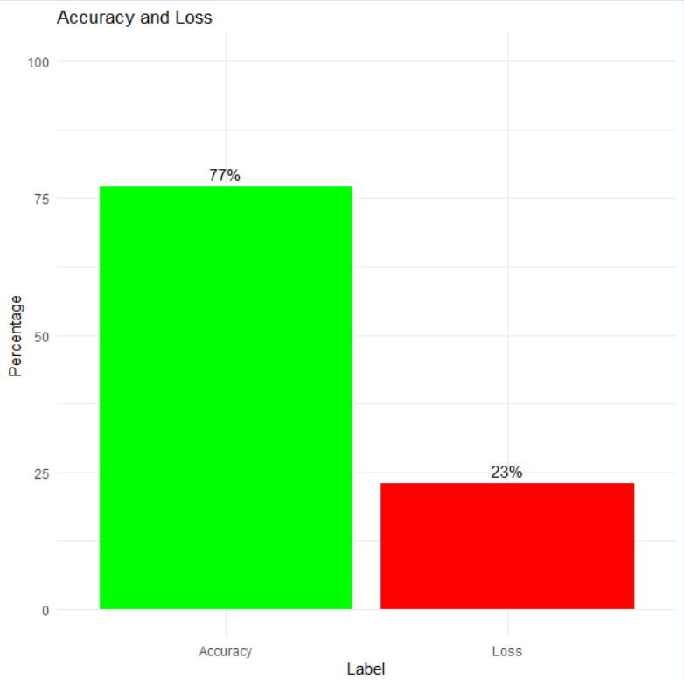

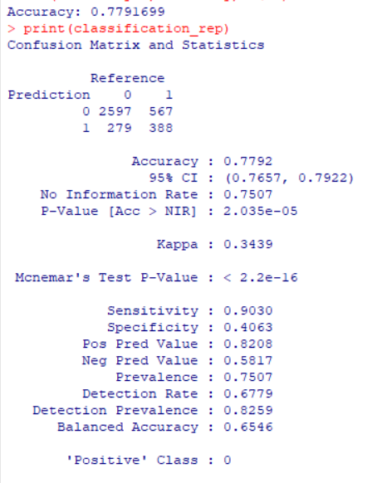

**METHODOLOGY**:

**1.** **Data Collection:** Gather relevant data for your analysis. This data may include employee demographics, performance metrics, salary information, employee surveys, and any other relevant HR-related data. Ensure that the data collected is accurate, complete, and relevant to your objectives.

**2.** **Data Preprocessing:** Clean and preprocess the collected data to ensure its quality and suitability for analysis. This step may involve handling missing values, removing duplicates, encoding categorical variables, scaling numerical features, and

other data cleaning tasks.

**3. Exploratory Data Analysis (EDA):** Conduct exploratory data analysis to gain insights into the data and understand its characteristics. Explore relationships between different variables, identify patterns, detect outliers, and visualize the data using graphs and charts.

**4. Feature Engineering:** Create new features or transform existing features to extract useful information that can improve the performance of your analysis models. This may involve feature scaling, dimensionality reduction, creating interaction terms, etc.

**5. Model Development:** Build predictive models or statistical models to address your HRM objectives. Depending on your specific goals, you may use various techniques such as regression analysis, classification algorithms, clustering, time series analysis, etc.

**6. Implementation:** Implement the recommendations derived from your analysis into HR management practices. Monitor the impact of these recommendations over time and iterate as necessary to achieve desired outcomes.

**7. Documentation and Reporting:** Document your analysis process, methodologies, and findings comprehensively. Prepare reports or presentations summarizing your analysis results, methodology, and recommendations for stakeholders' reference.

**RESULT:**

The HR analysis is anticipated to yield tangible benefits, including heightened employee satisfaction and engagement levels, which can positively impact organizational performance. Improved performance management strategies should lead to the identification of high-performing talents and areas for skill enhancement. Effective talent management initiatives are expected to streamline recruitment processes, resulting in reduced time-to-fill for open positions. Optimizing compensation and benefits based on industry benchmarks should contribute to higher retention rates and overall employee contentment.

**Conclusion:**

The HR analysis underscores the importance of targeted interventions in areas such as employee satisfaction, performance management, and talent development. The anticipated positive shifts, including heightened engagement and strategic alignment, emphasize the potential impact of data-informed HR decisions. Implementing these insights is vital for creating a workplace culture that fosters employee well-being and aligns with organizational objectives. The ongoing monitoring and adaptability of HR strategies are essential to navigate evolving challenges and sustain positive changes in the workforce.

**References**

[1] T. N. Phyu, “Survey of classification techniques in data mining,” in Proceedings of the International Multiconference of Engineers and Computer Scientists, vol. 1, 2009, pp. 18–20.

[2] H. Jantan, A. R. Hamdan, and Z. A. Othman, “Human talent prediction in HRM using c4. 5 classification algorithms,” International Journal on Computer Science and Engineering, vol. 2, no. 8, pp. 2526–2534, 2010.

[3] I. H. Witten, E. Frank, M. A. Hall, and C. J. Pal, Data Mining: Practical machine learning tools and techniques. Morgan Kaufmann, 2016.

[4] L. A. Kurgan and P. Musilek, “A survey of knowledge discovery and data mining process models,” The Knowledge Engineering Review, vol. 21, no. 1, pp. 1–24, 2006.

[5] H. Liu, R. Setiono et al., “A probabilistic approach to feature selection-a filter solution,” in ICML, vol. 96. Citeseer, 1996, pp. 319–327.

[6] M. A. Hall, “Feature selection for discrete and numeric class machine learning,” 1999.